Backgroup
I stored all my SimpErhu files on OneDrive, I can open the files on my computer perfectly but not on my iPhone/iPad. (See picture below) This is because the SimpERhuFont.ttf is not installed on my iPhone/iPad and I want my SimpErhu files on iPhone/iPad for easier to perform. After a little research, found a way to install the font to my iPhone/iPad with the $0.99 USD All Fonts app from App Store

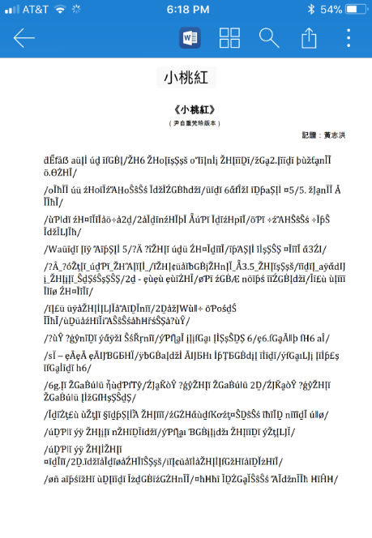

Environment under test
- iPhone 7 Plus (iPad should work the same way)
- Microsoft Office 365 (can use the free version of Word from App Store)
- OneDrive space (everyone can sign up for a free 5GB space)
- Windows 10 Computer (Should work on any Windows, just need a browser)
- Require the $0.99 All Fonts app from App Store (search App Store to find it)
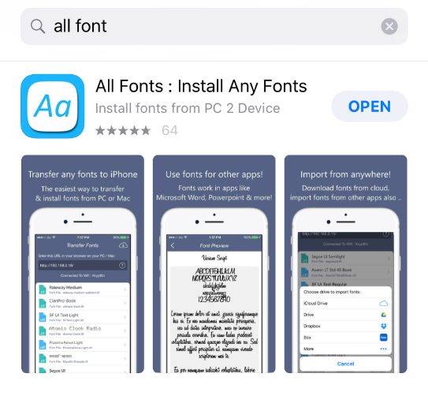
Note: I believe I saw something similar for Android tablet too, but I only document this for iPhone/iPad

Procedure to get SimpErhuFont.ttf to iPhone/iPad
- Getting the SimpErhuFont.ttf to iPhone/iPad
- Installing the SimpErhuFont.ttf t iPhone/iPad
- Opening SimpErhu file

Getting the SimpErhuFont.ttf to iPhone/iPad (Only need to do this once)
- Computer and iPhone/iPad need to be on the same WiFi network
- On iPhone/iPad: Launch the All Fonts app. There is no font file show at first, note the URL shown in the app. (Don't use the IP number shown here, everyone will have his own)
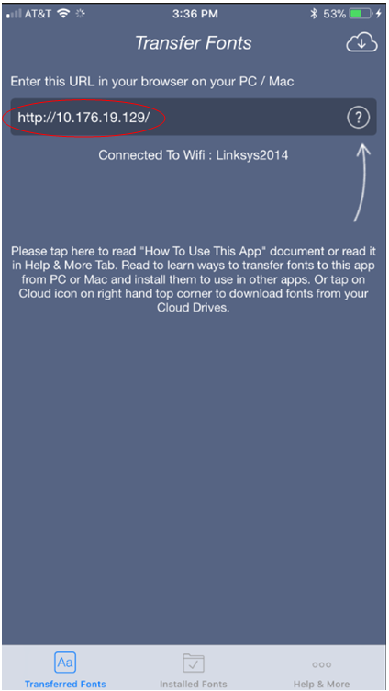

- On computer: Launch a browser
  - Type the URL showed on the iPhone/iPad into the browser. It'll see your iPhone/iPad and no .ttf file
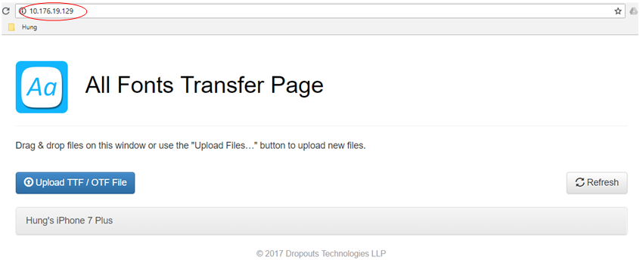

- Now locate your SimpErhuFont.ttf file your downloaded from SimpErhu web site, drag & drop it to your browser; and the SimpErhuFont.ttf now show in the browser
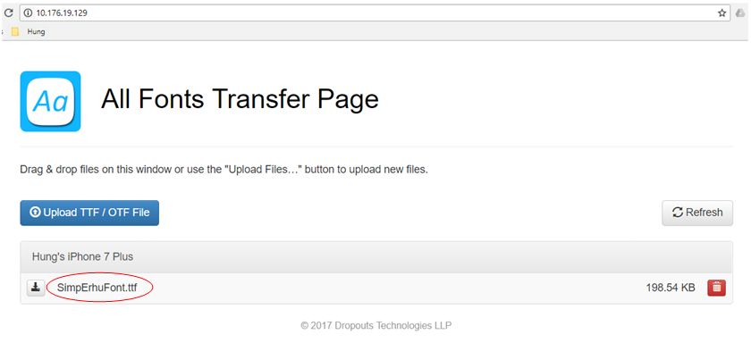

- Watch your iPhone/iPad, the SimpErhuFont.ttf is also showed. The .ttf file is now on your iPhone/iPad.
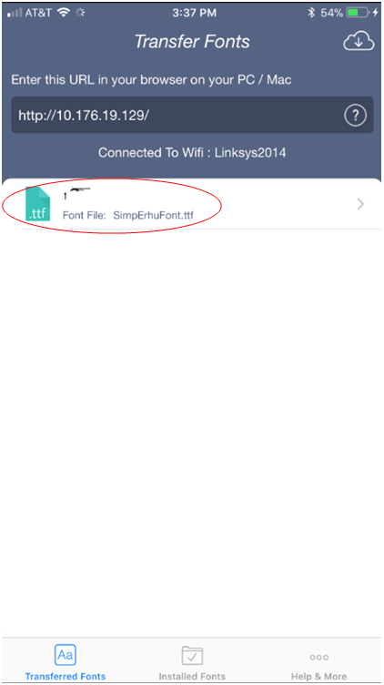

Installing the SimpErhuFont.ttf t iPhone/iPad (Only need to do it once)
- On iPhone/iPad:
  - Tap the copied SimpErhuFont.ttf to show the Font Preview, tap the Install Font blue banner at the bottom
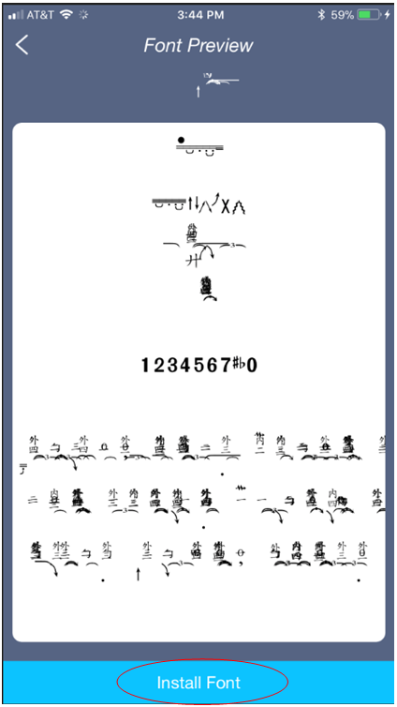

- A Safari window pops up with a confirmation window, just tap Allow
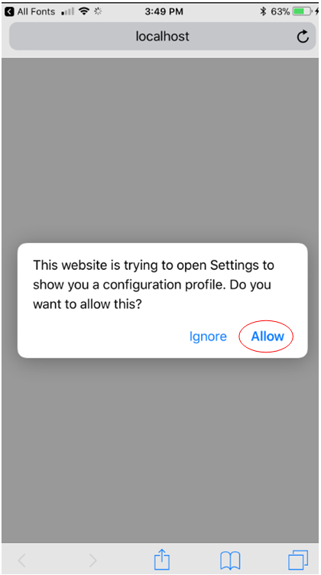

- Sometime the Safari window shows an error message without the confirmation window, then tap the upper-left to go back to the Font Preview and click Install Font blue banner again
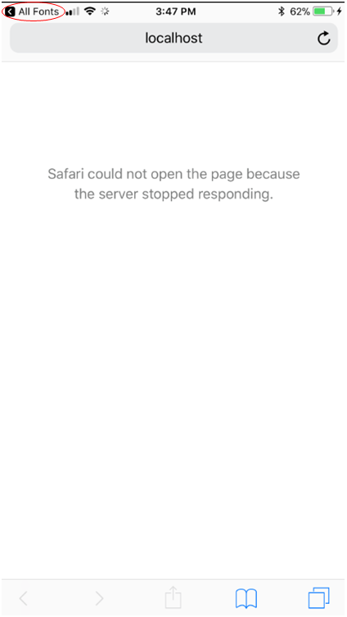

- A Settings page pops up, tap install from the upper-right corner
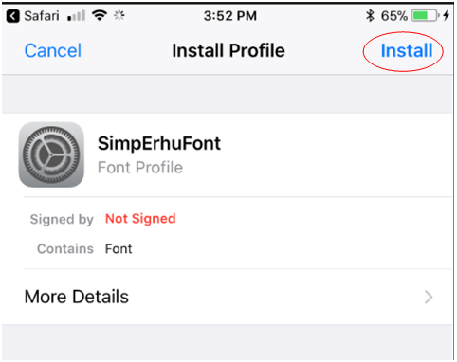

- Enter your iPhone/iPad Passcode when being asked
- A Warning page pops up, tap install from the upper-right corner again
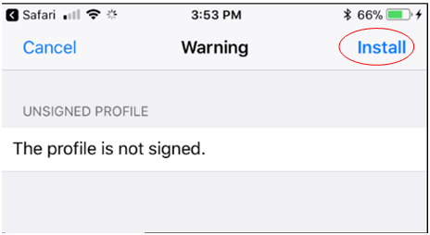

- Then tap the Install button at the bottom
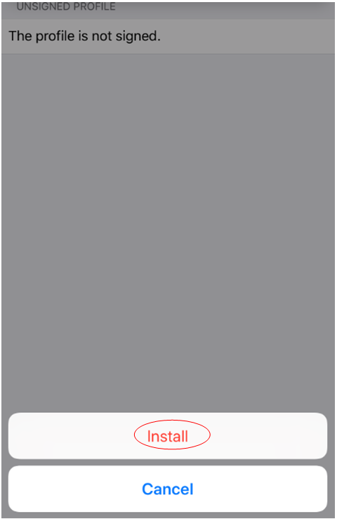

- This is it. Your font is installed, tap Done from the upper-right corner
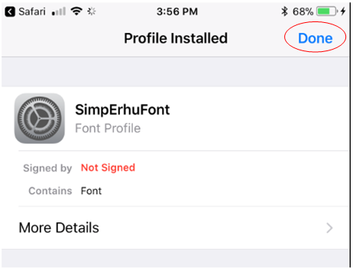

- It might bring you back to the Safari webpage, then just exit that webpage

Opening SimpErhu file
- Assuming you have your SimpErhu file on OneDrive
- Launch the Microsoft Word app
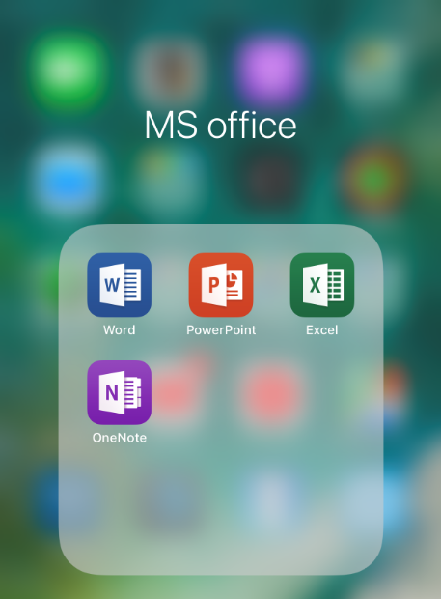

- Browse through your OneDrive folder and select the desired file
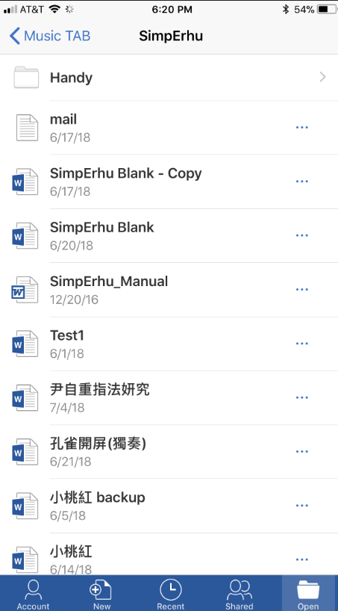

- Voila, your SimpErhu file is opened with the correct font
